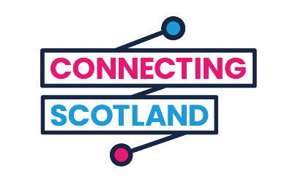
Connecting Scotland Digital Champions

What is a Digital Champion?
Digital Champions help people who get devices through Connecting Scotland to do things online like:
- helping people set up their new devices
- using video calls and messaging apps
- accessing online learning opportunities
- explaining how to stay safe online
The aim is that, with support from Digital Champions, learners will be able to use the internet safely, confidently and effectively.
Digital Champions usually work in frontline positions in third and public sector organisations. For example, support workers, advice officers or befriending volunteers.
But all staff who come into regular contact with service users can be Digital Champions.
Being a Digital Champion isn’t another role you need to take on – it’s a process of upskilling. Supporting people with their digital skills enables them to engage with your services and work towards better outcomes across other aspects of their lives e.g reducing social isolation, saving money by being online. Promoting digital inclusion is everyone’s responsibility, especially in the current context of the global pandemic.

What skills and qualities does a Digital Champion need?
You do not need to be a technology expert to be a Digital Champion. But you do need to be confident in your own digital skills. You can check your own skills using the Essential Digital Skills toolkit. This will identify any gaps in your knowledge and areas where you may want to improve. You can also use this toolkit with the people you’re supporting.
The most important qualities in a Digital Champion is their people skills:
- Friendly, approachable, and eager to help others learn new skills
- A good listener
- Ability to explain things in simple terms
- An understanding of people’s interests and motivations for learning
- Passionate about the positive impact digital can have on people’s lives
- Patience

How much time does it take?
Support sessions with learners usually take place in person, once or twice a week. But if it’s only possible to provide support sessions remotely, they’ll take place on the phone.
30 – 45 minutes is usually enough time to make some progress without overwhelming the learner. When you first help someone set up their devices this can take a bit longer.
All this will depend on who you’re working with and what they need. It also depends on how your organisation usually delivers support. The best approach is to embed digital skills in the core support you provide to your users. For example, if you’re helping someone manage their finances you could explore apps for budgeting or do price comparisons online to reduce the costs of household utilities.
The support relationship should last for up to 6 months. But it could be shorter if your learner picks up all they need, or want, to know pretty quickly.

What support can I get?
We have a Digital Champion hub on the Connecting Scotland website, full of resources to help you in your role as a Digital Champion.
If you’re struggling in an aspect of support you can contact the Connecting Scotland team at help@connecting.scot or call the Connecting Scotland helpline on 0800 0 590 690
You can also have your experience as a Digital Champion formally recognised through a qualification. SCVO and Glasgow Kelvin College have developed two credit rated qualifications that you can access online and for free:
- Certificate in Digital Inclusion Support – SCQF Level 4
- Essential Skills for Digital Champions – SCQF Level 6
You can find out more and enrol for these courses here.

