Congratulations on your successful application to Connecting Scotland!

We understand that you may want to share the news internally with your colleagues and externally to wider stakeholders, so we’ve provided some content suggestions below on how you can do this.

Sample social media posts

Below are some sample tweets you are welcome to edit and use but please feel free to create your own using your organisation’s examples and wording/tone, along with the #connectingscotland hashtag (you can also tag the following accounts: @digitalscots @scotgovfairer @scvotweet @digiscot):

- Delighted to announce that we’ve been awarded [insert number] devices from #ConnectingScotland to help people get online! Find out more about the programme at https://bit.ly/2U7J64Z @scotgovfairer @SCVOtweet @digiscot

- #ConnectingScotland is making a huge difference to the lives of people all over Scotland & we’re delighted to have been awarded [insert number] devices to help digitally excluded households in [insert local area]! Find out more about the programme at https://bit.ly/2U7J64Z @scotgovfairer @SCVOtweet @digiscot

- The #ConnectingScotland programme aims to reduce digital exclusion, & we’re delighted to be a part of the movement having received [insert number] devices to support people in our community! Find out more about the programme at https://bit.ly/2U7J64Z @scotgovfairer @SCVOtweet @digiscot

- Around 800,000 people in Scotland faced digital exclusion. Here at [insert organisation name] we’re reducing that number to get [insert number] people online with #ConnectingScotland! Find out more about the programme at https://bit.ly/2U7J64Z @scotgovfairer @SCVOtweet @digiscot

Social media graphics
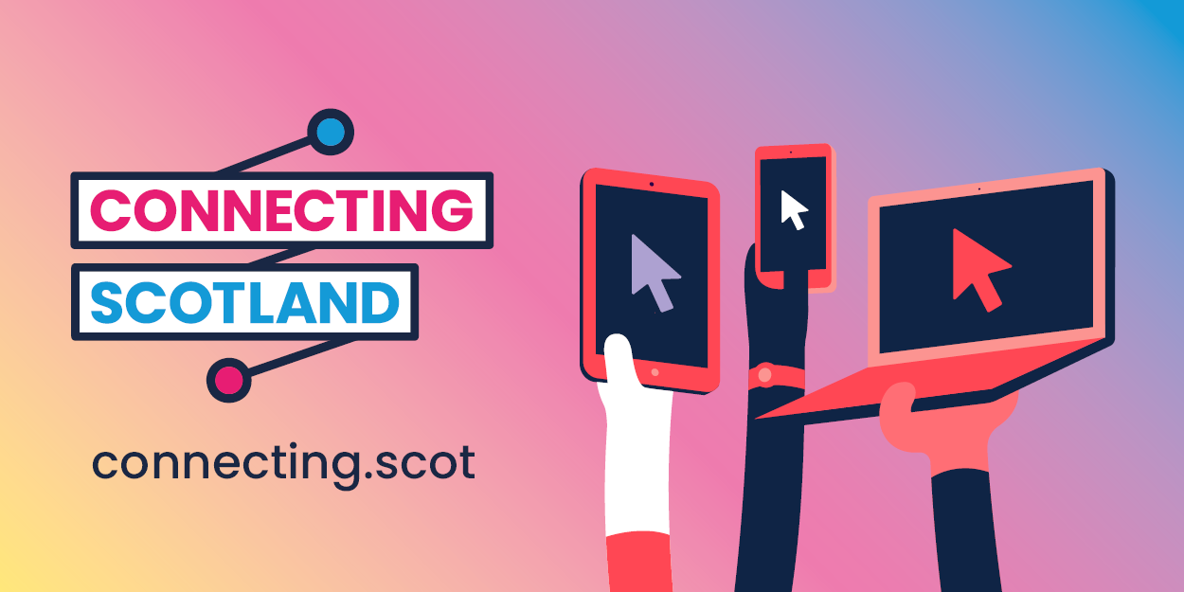
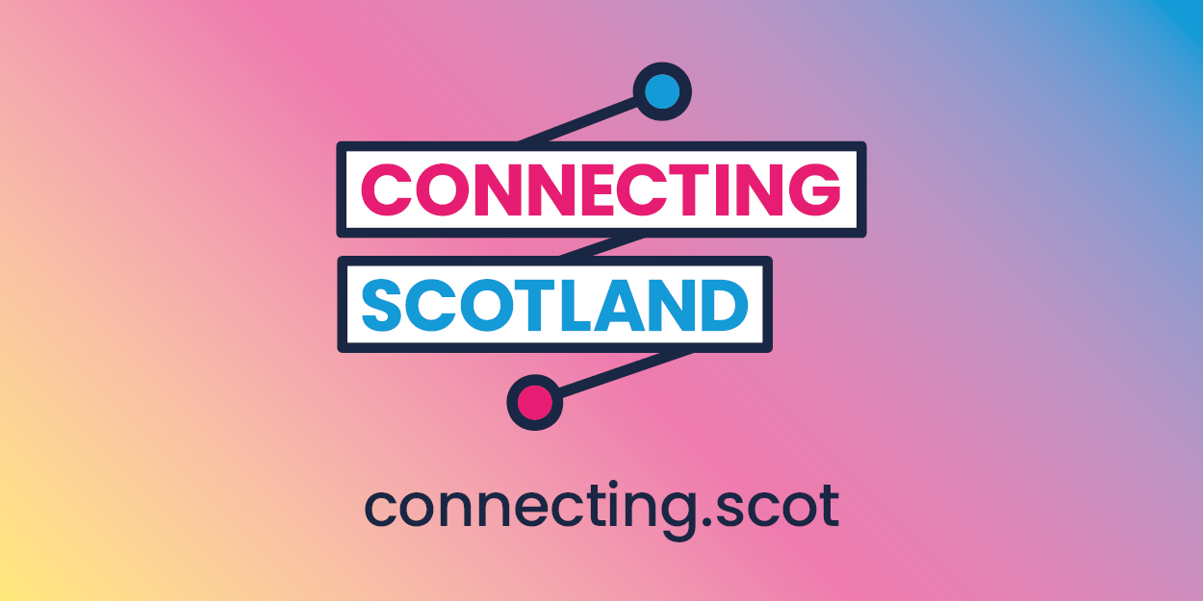
Accessibility
If you are using graphics on social media please include a description of the image in ‘description’ or ‘alt-text’ to make it more accessible for those with visual impairments (you can simply use ‘Connecting Scotland logo/graphic’ if you are using the ones provided above).

Sample email

We are delighted to announce that our application to the Connecting Scotland programme was successful. As a result we will now receive [insert number] kits (devices and mifis) to go towards low income, digitally excluded families and young care leavers.

In addition, [insert number] staff will receive training to become ‘Digital Champions’ who will be paired with recipients to support them through the set-up and use of their device.

The Connecting Scotland programme aims to reach 50,000 people by the end of 2021 – to find out more visit https://connecting.scot/ .

Case studies

We’re always looking to capture the stories of those involved in the Connecting Scotland programme and receiving support. If you would like to share your story please email help@connecting.scot

